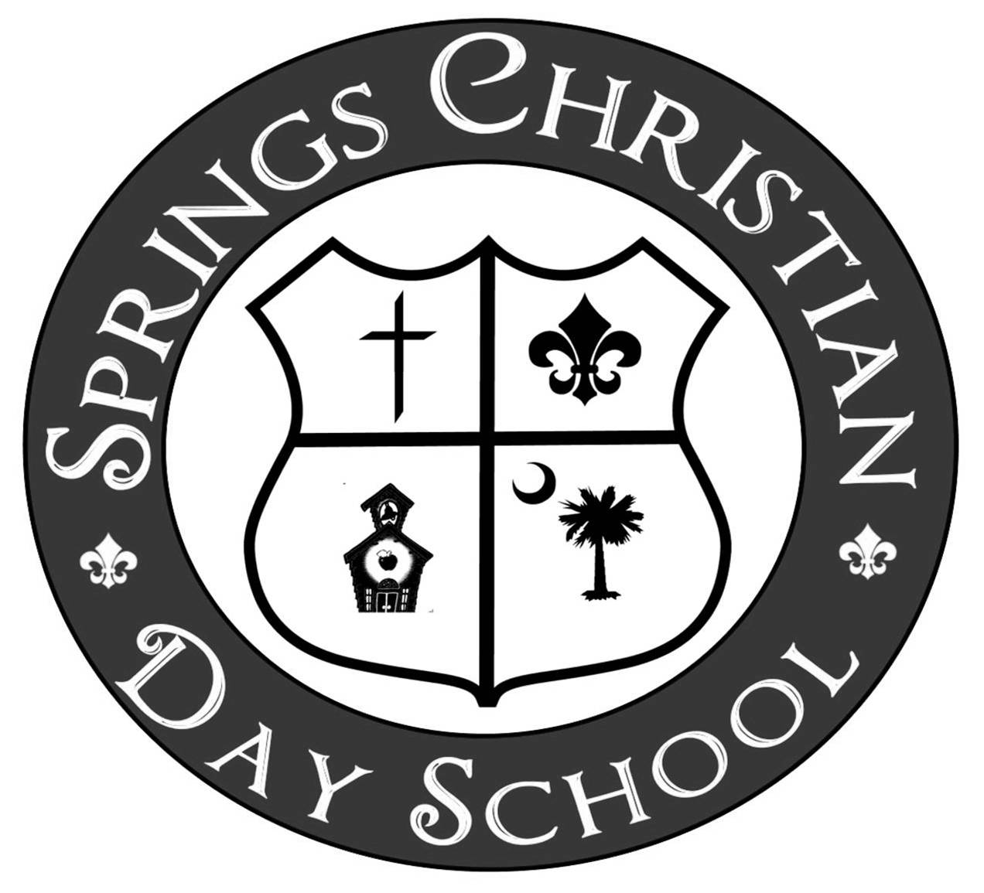
Summer Care Program Fees and Tuition Policies
Summer 2024

Who Can Attend? Our Summer Care Program is available for children ages 1 year old through K4 who, with the exception of our current 4K students, will be attending SCDS in the 2024-2025 school year.

Hours of Operation: We will be open from 7:00 am until 5:45 pm. The first week of Summer Care will be May 27-May 31, 2024, and the last week of Summer Care will be July 29-August 2, 2024. We will be CLOSED Monday, May 27, Thursday, July 4th, and the week of July 22-26.
The week of May 20-24 is available only for students currently enrolled in our Extended Care program. These children will attend their regular Extended Care schedule that week. August 5-9, 2024, will be available only for students who have registered to attend SCDS Extended Care for the 2024-2025 school year. These children will attend their regular Extended Care schedule that week. If your child will not be attending the SCDS Extended Care Program in 2024-2025, their last day of summer care will be Friday, August 2, 2024.

Registration Fee: A one-time registration fee of $100.00 (Non-refundable.) will be charged for all students.

Tuition & Enrollment: Summer Care Program enrollment/reservation should be made up to one week in advance. Please let us know at least one week in advance if your child will not be attending. Tuition is to be paid one week in advance of attendance. All payments must be made by cash, check, or money order and put in the tuition box at the front desk. If paying in cash, please bring the exact amount owed. The SCDS office does not keep cash on hand for change. SCDS does not accept debit or credit cards and the online payment system is not available in the summer. PLEASE NOTE: You are expected to pay for the number of days you registered for on your application even if in a given week you do not attend the full number of days you have reserved. For example, if you are registered for 5 days per week and you attend any number of days less than the 5 days, you are still expected to pay for the 5 days you reserved. We do not prorate tuition for voluntary absences. We will be CLOSED the week of July 22-26, 2024. (No payment is required for the week of July 22-26. Payment is REQUIRED for the rest of the summer weeks.)

Snacks/Lunches/Naps: Morning and afternoon snacks will be provided. Students staying past 11:30 will need to bring a lunch daily, including a drink. We do not refrigerate or heat lunches. Students will take a nap each day. PLEASE send a no glass refillable water bottle daily for your child to drink from throughout the day, it MUST be labeled with your child’s name on it.

Refunds: There will be no refunds given and tuition will not be prorated for voluntary absences. Students who attend 3 days or 5 days a week will receive a prorated tuition amount for the weeks of May 27-May 31 and July 1-5 because the school will be closed on Monday, May 27 and Thursday, July 4.

Returned Check Fee: A fee of $35.00 will be assessed to your account for any returned checks.

Ages: 2 YR- 4K
 | 7:00-11:30 | 7:00-2:00 | 7:00-5:45
2 Days | $90 | $103 | $115
3 Days | $120 | $133 | $145
5 Days | $170 | $183 | $195

